**LAPORAN PRAKTIKUM**

**PEMROGRAMAN BERORIENTASI OBJEK 3**



Nama : Ghifar Januar Abdillah

NPM : 4523210051

**Dosen : Adi Wahyu Pribadi**

**S1-Teknik Informatika**

**Fakultas Teknik Universitar Pancasila**

**2024/2025**

# SINGLE

## Mobil.java

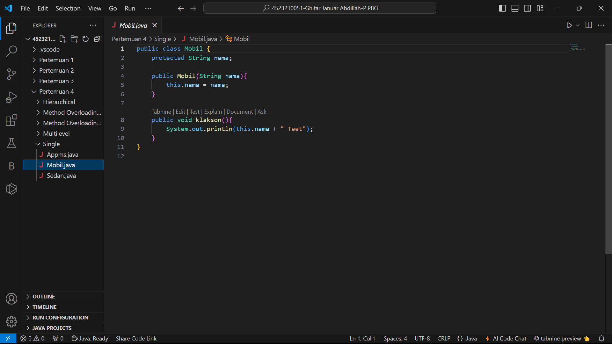

## Sedan.java

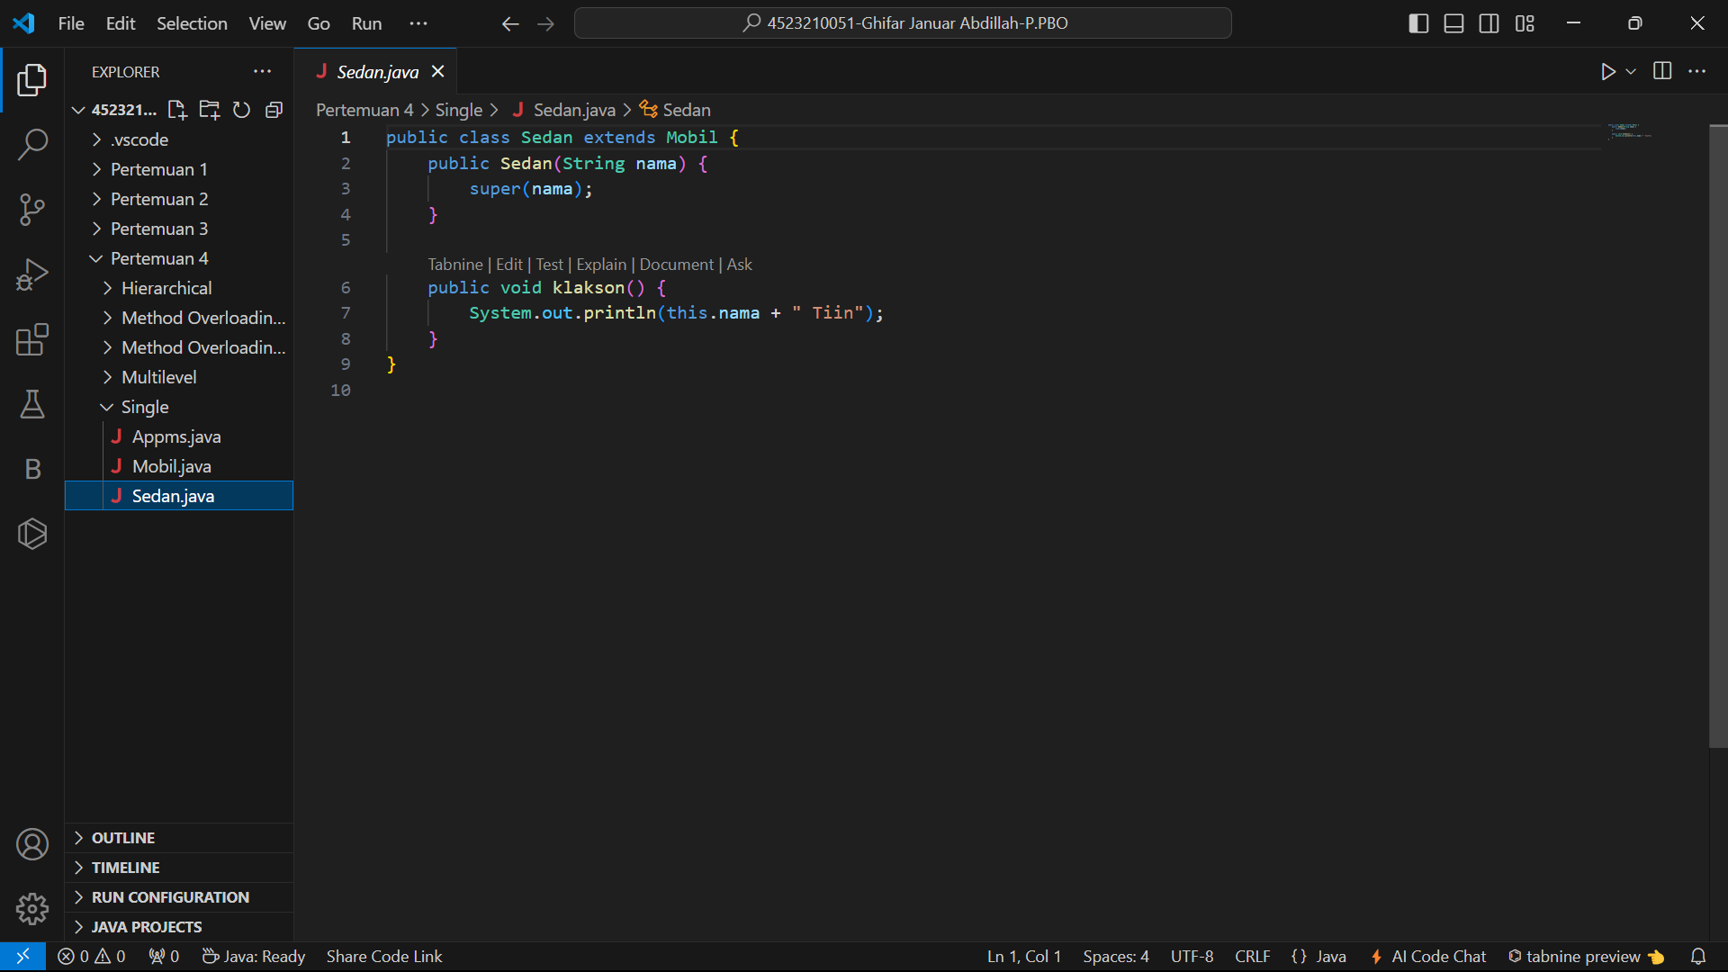

## Appms.java

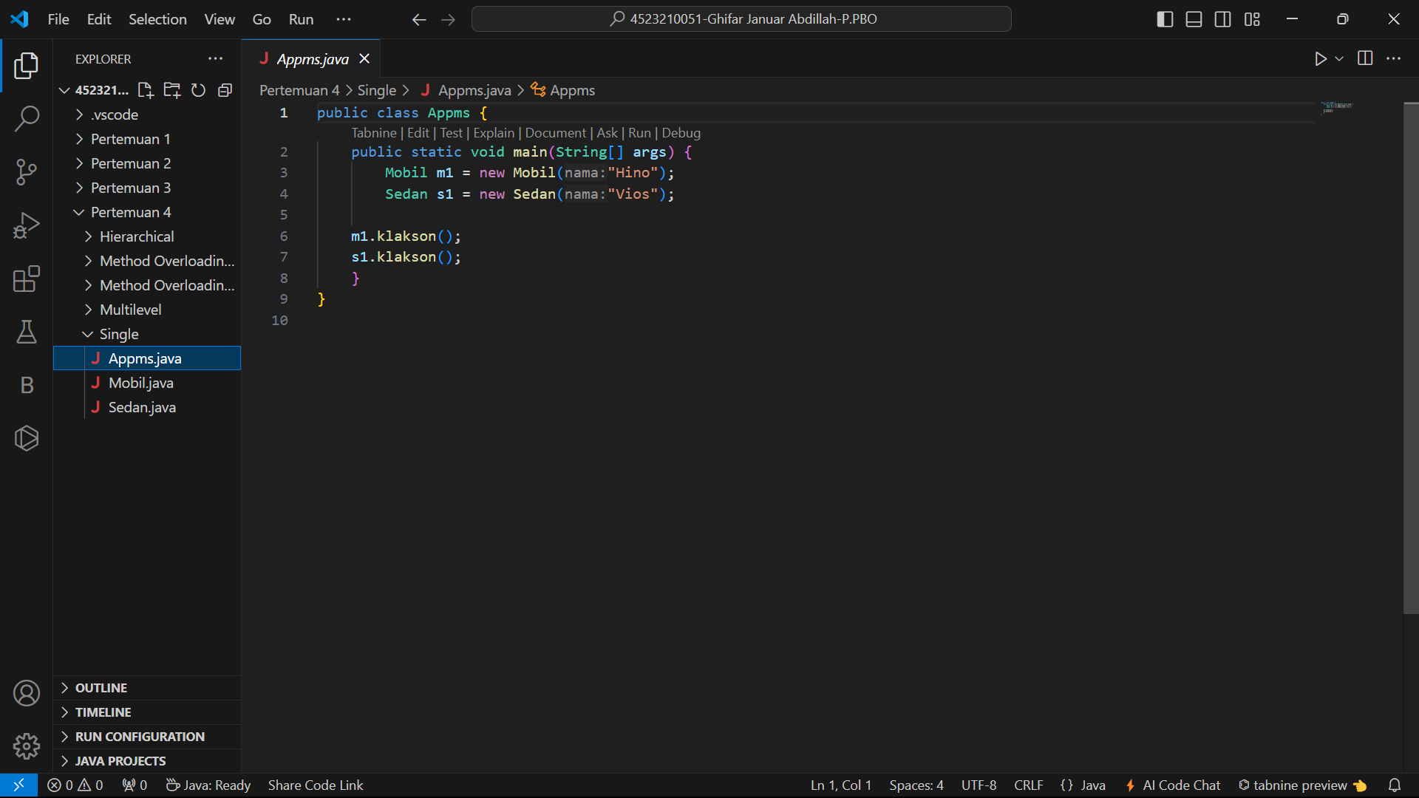

# Hasil Running



# MULTILEVEL

## Binatang.java

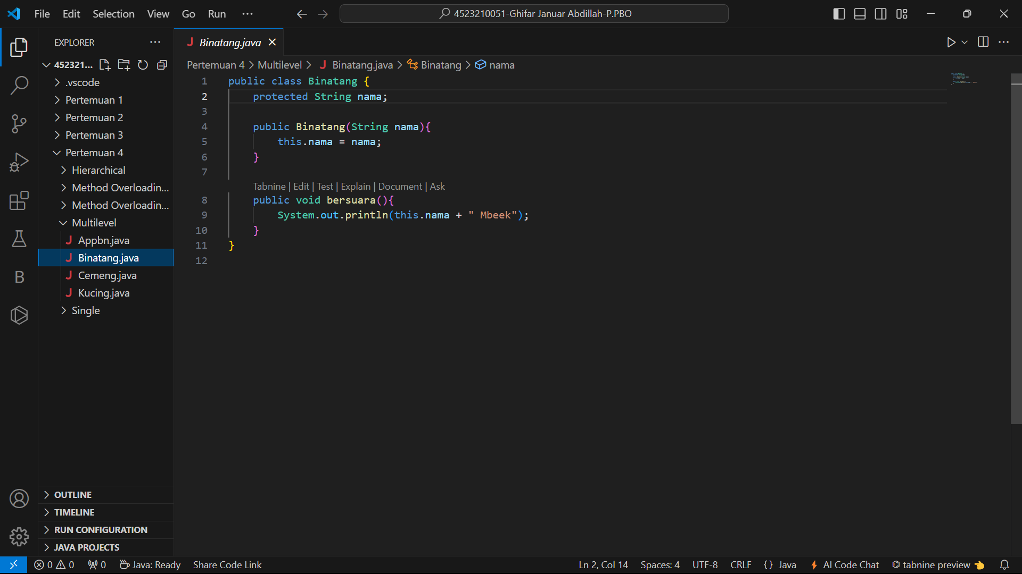

## Kucing.java

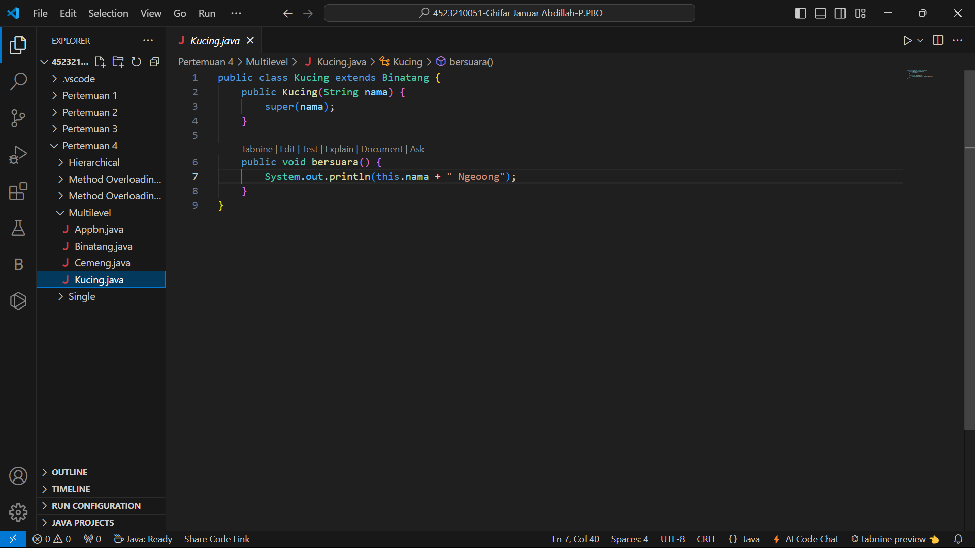

## Cemeng.java

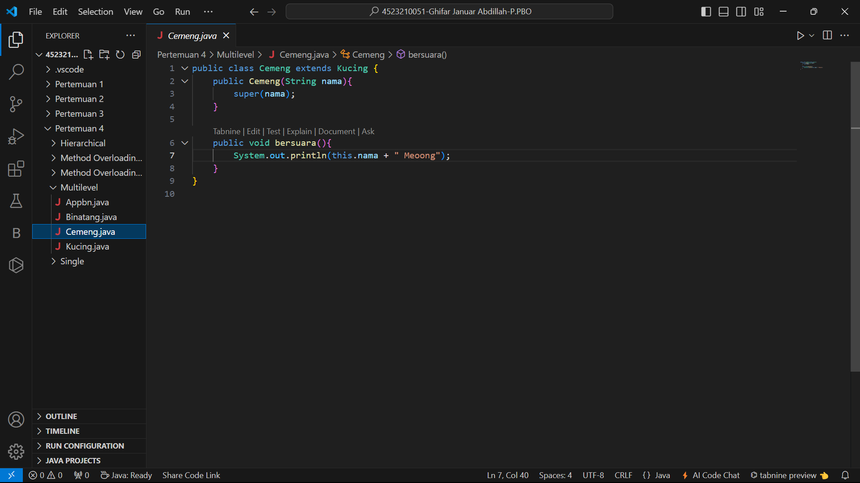

## Appbn.java

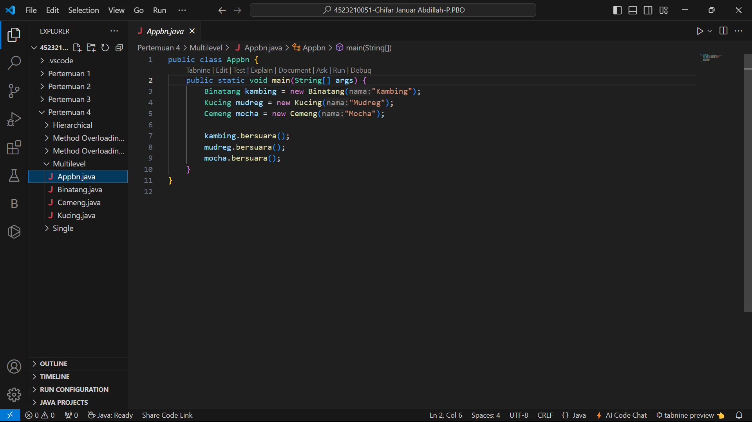

# Hasil Running

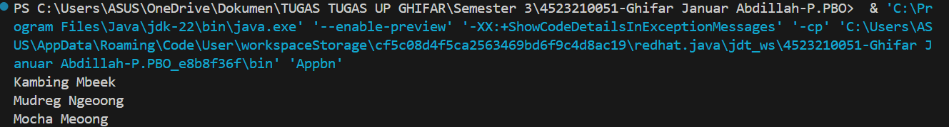

# HIERARHICAL

## Karyawan.java

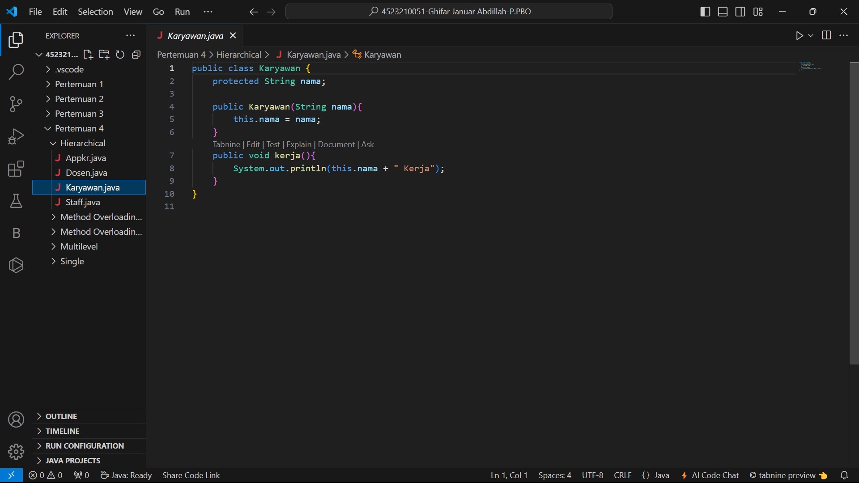

## Dosen.java

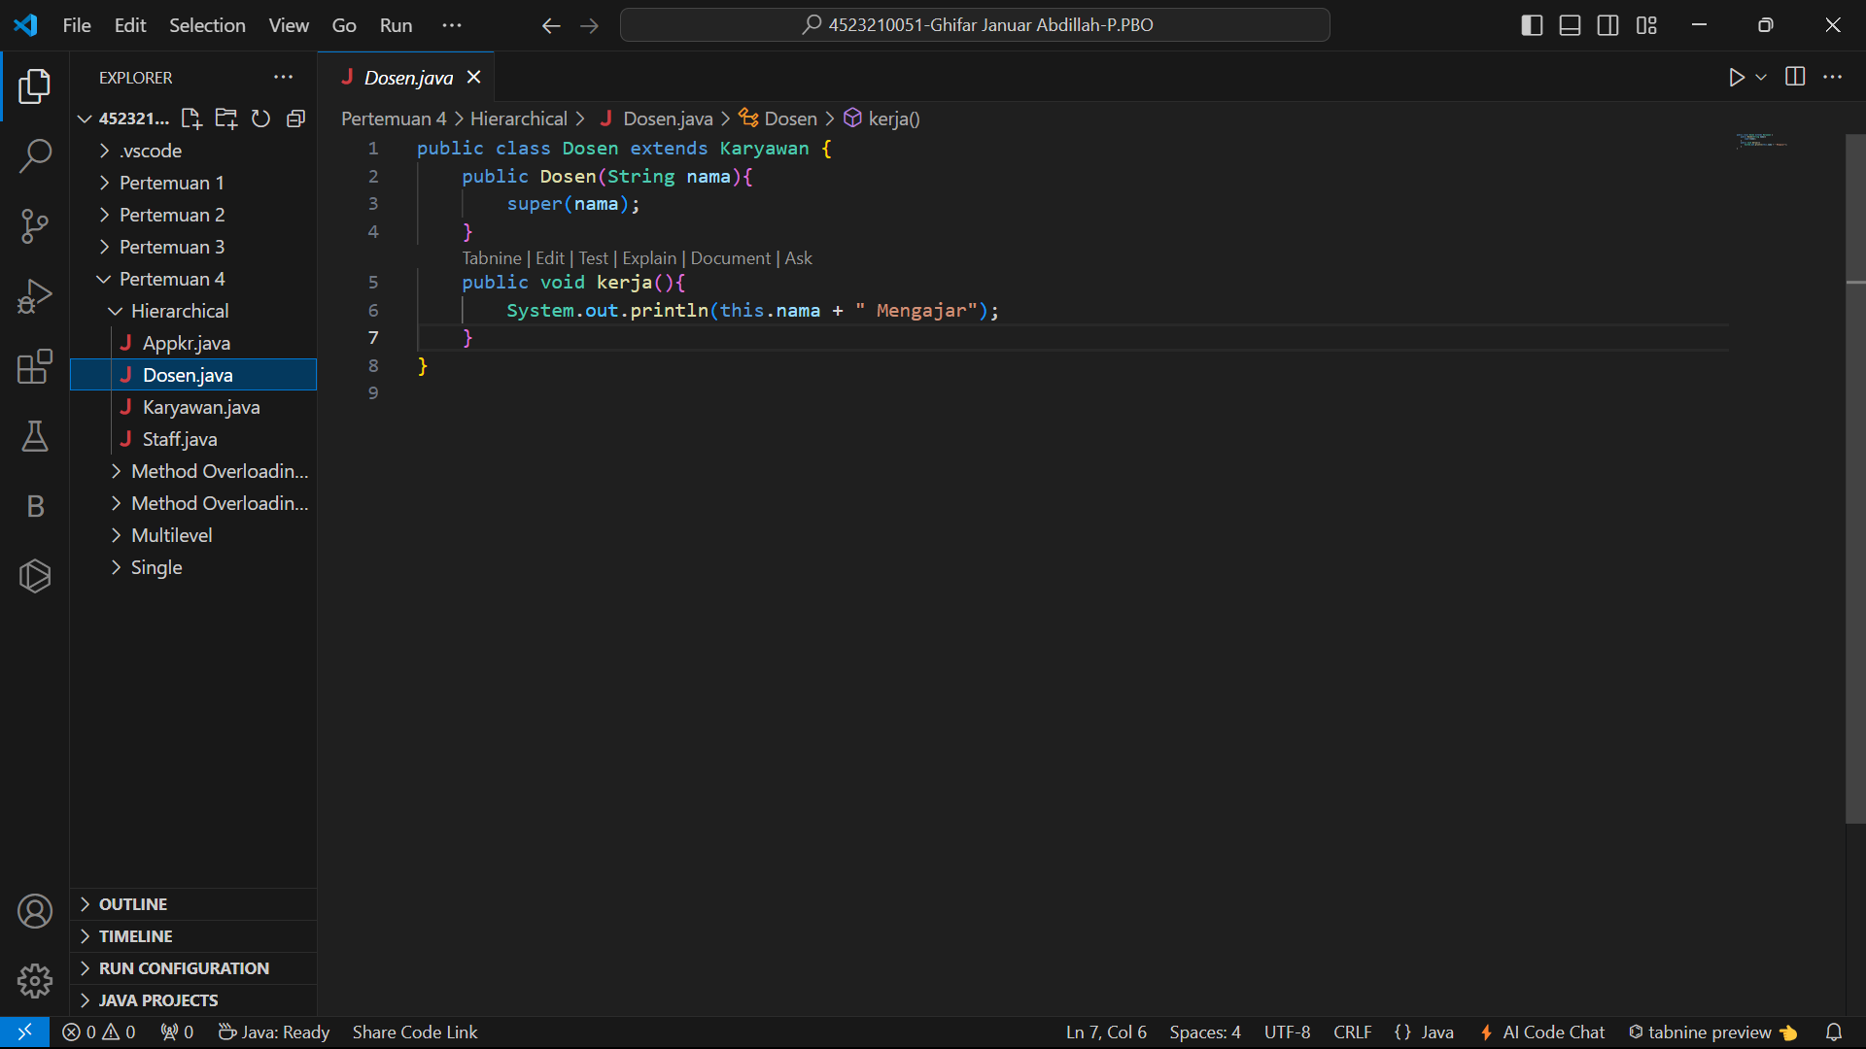

## Staff.java

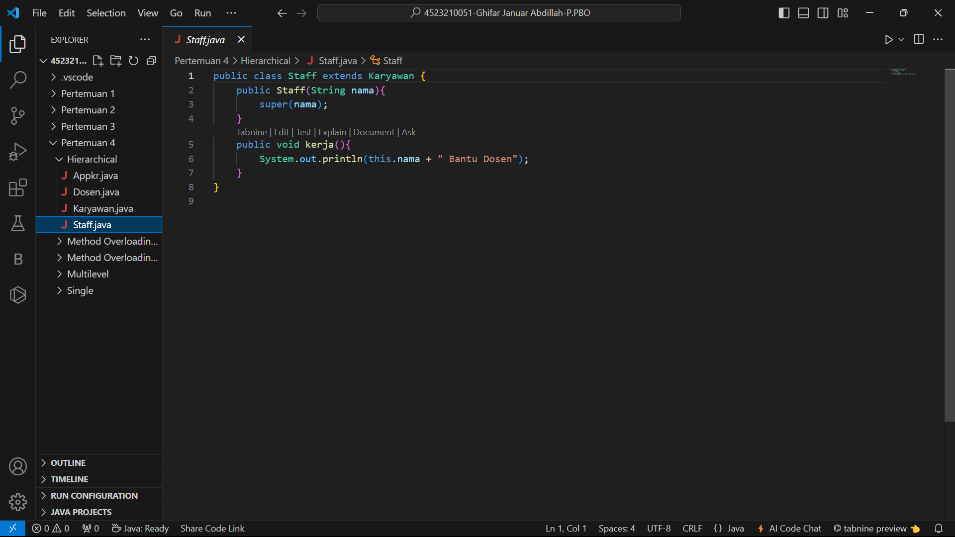

## Appkr.java

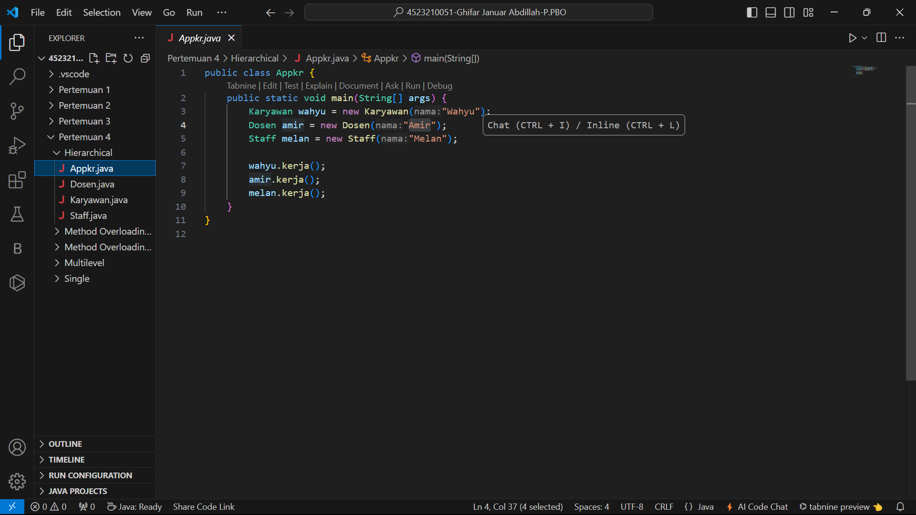

# Hasil Running

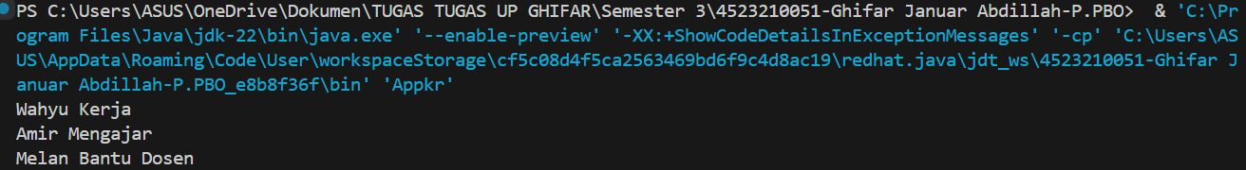

# Method Overloading / Static Polymorphism 3.1

## MobilSport.java

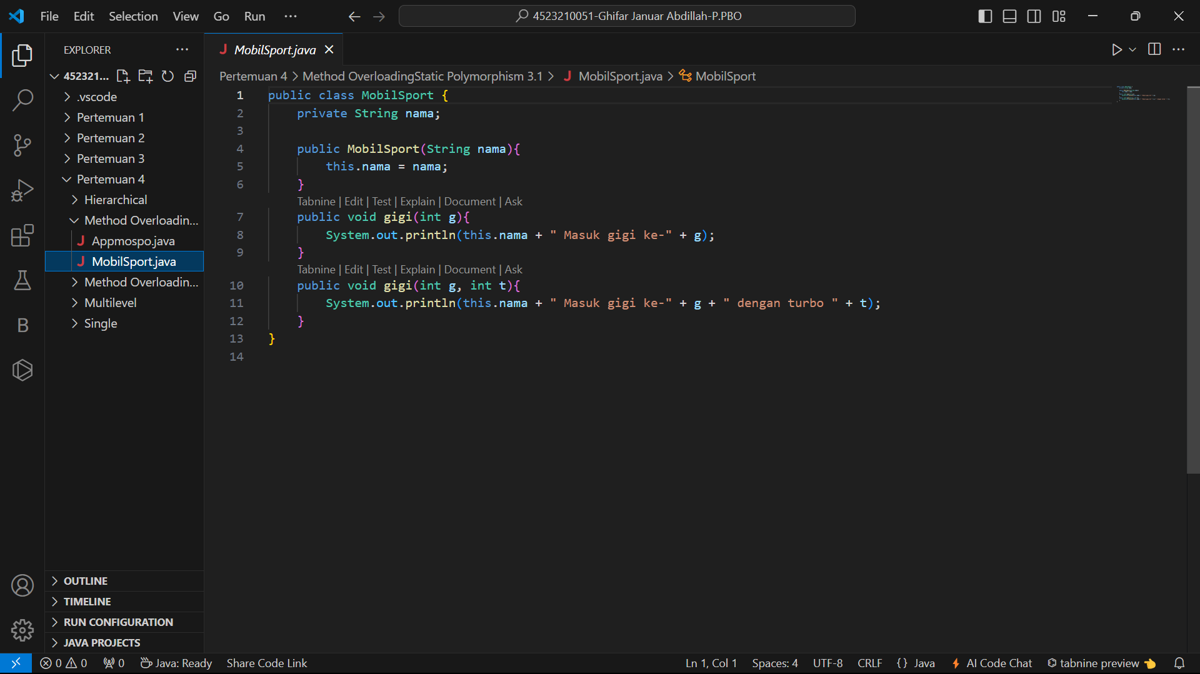

## Appmospo.java

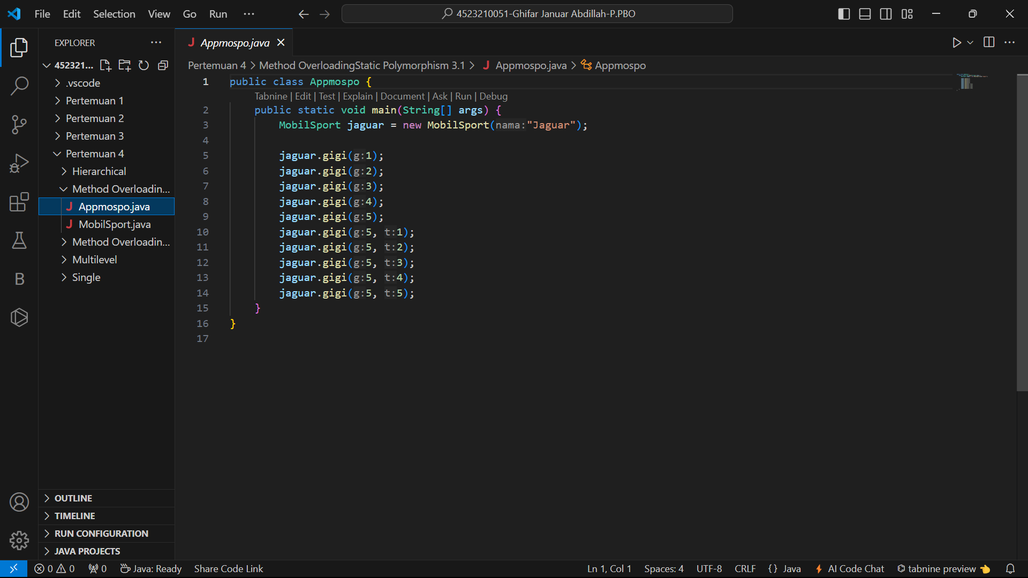

# Hasil Running

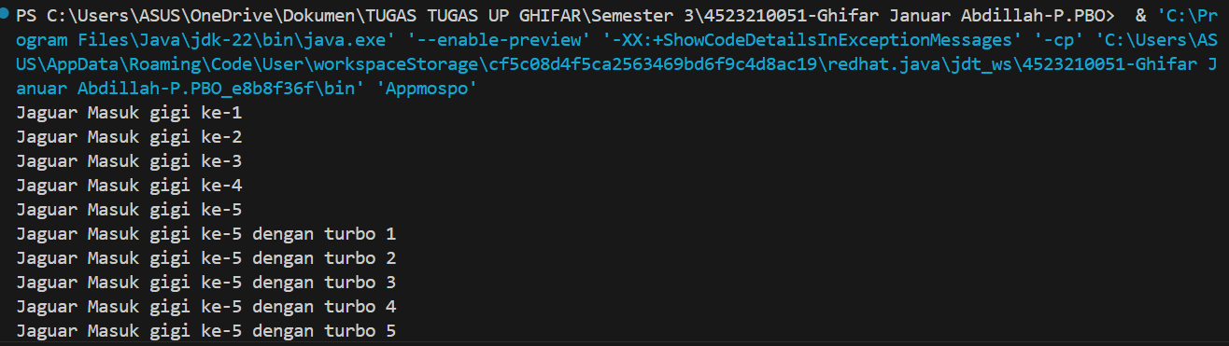

# Method OverloadingStatic Polymorphism 3.2

## BangunDatar.java

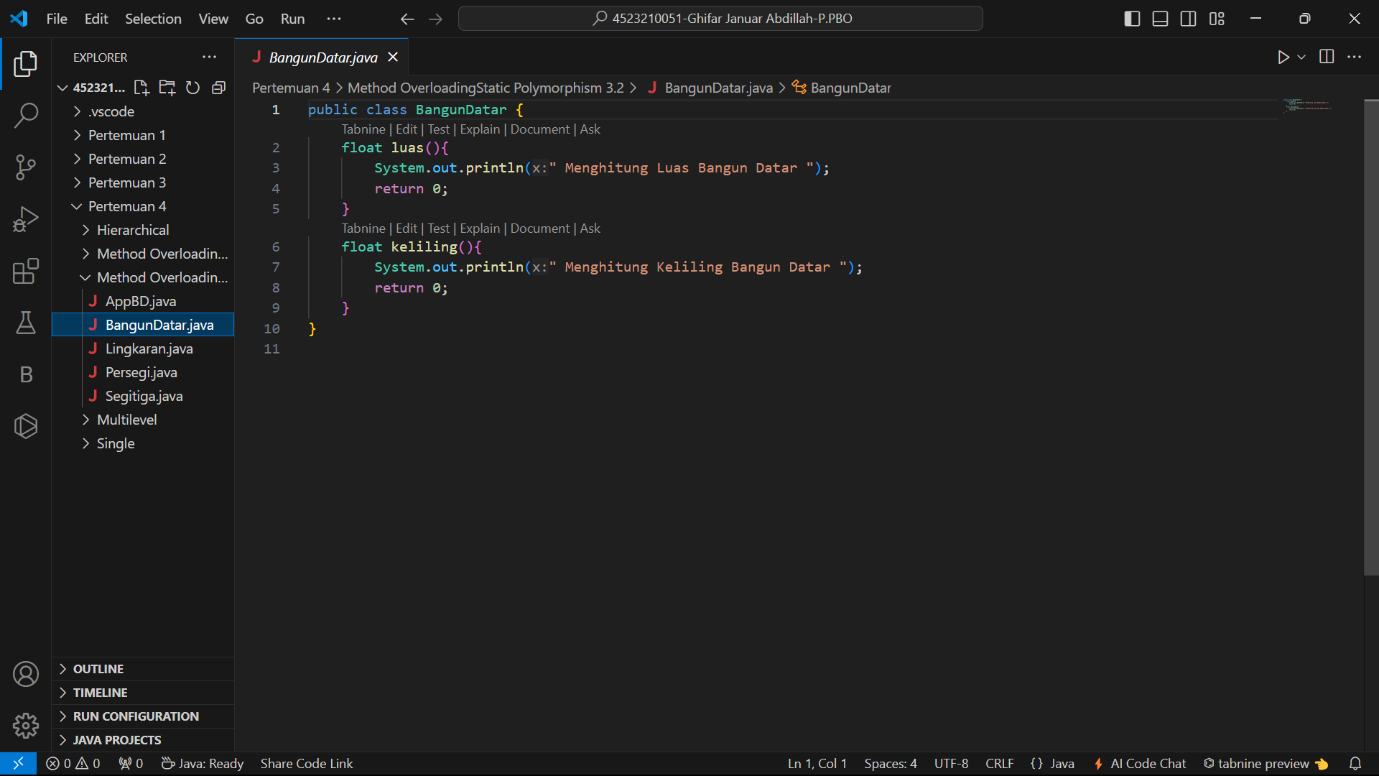

## Persegi.java

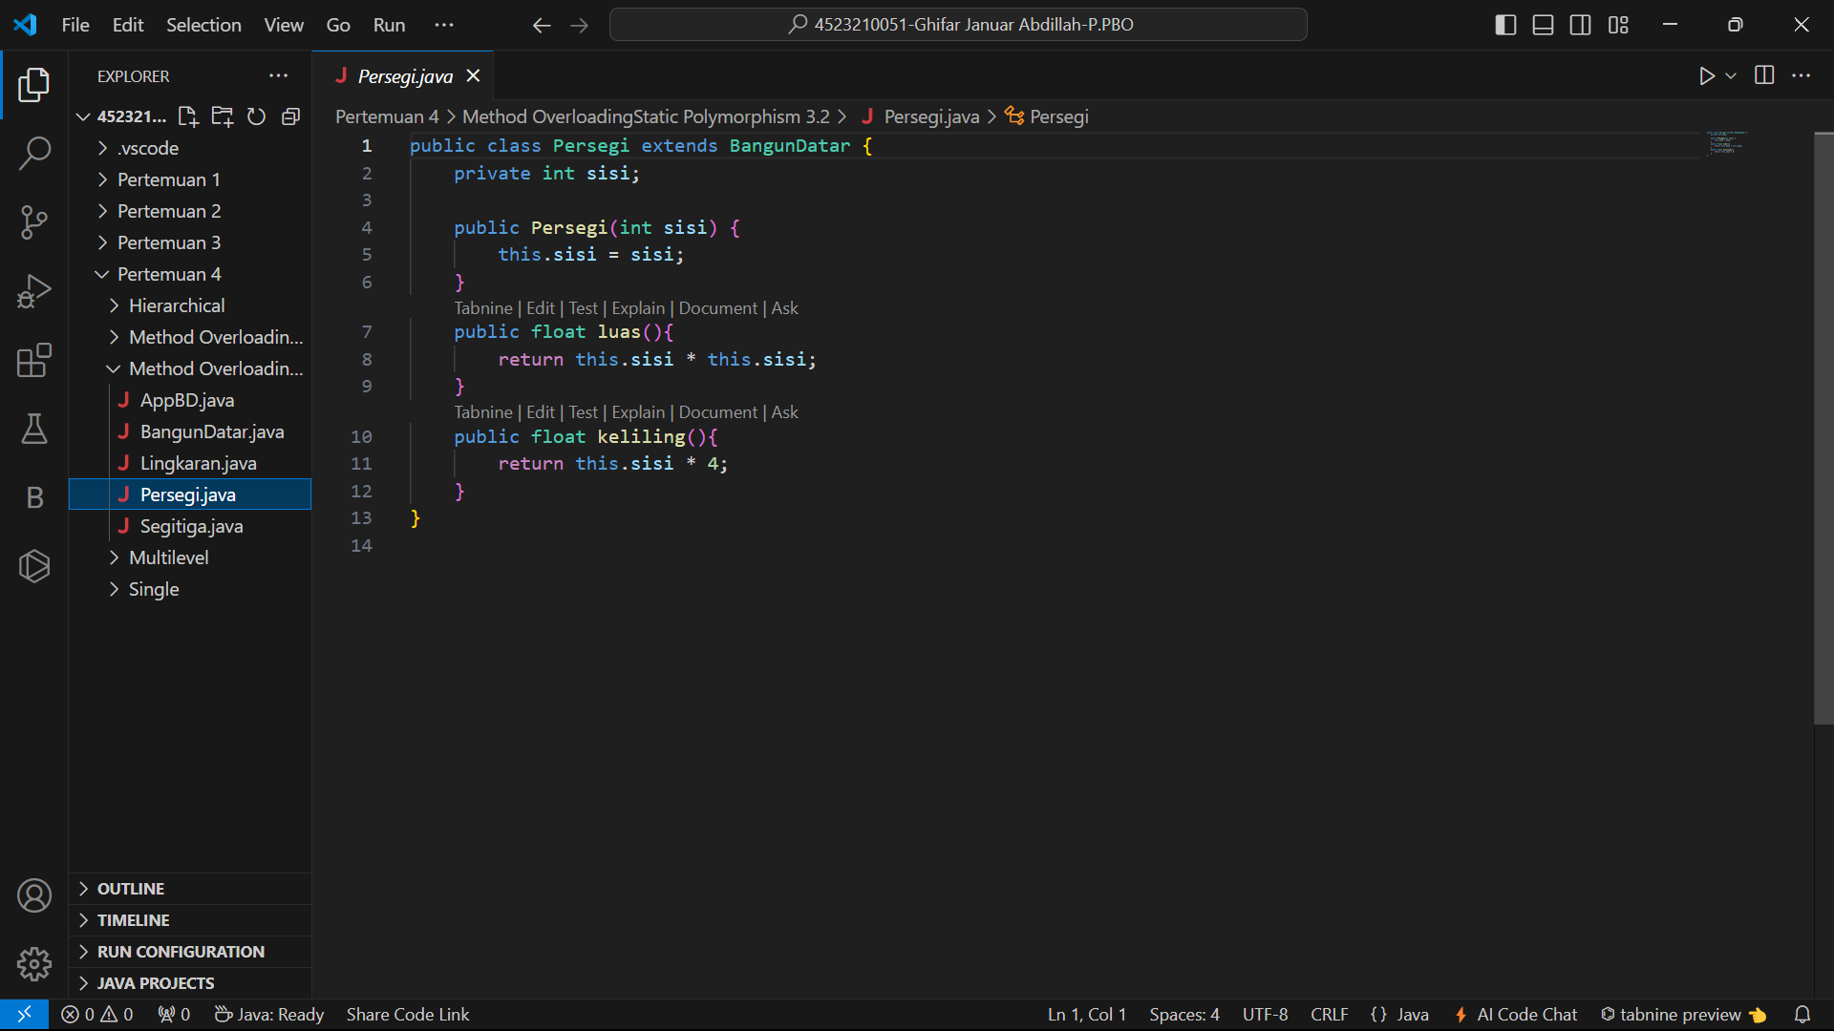

## Segitiga.java

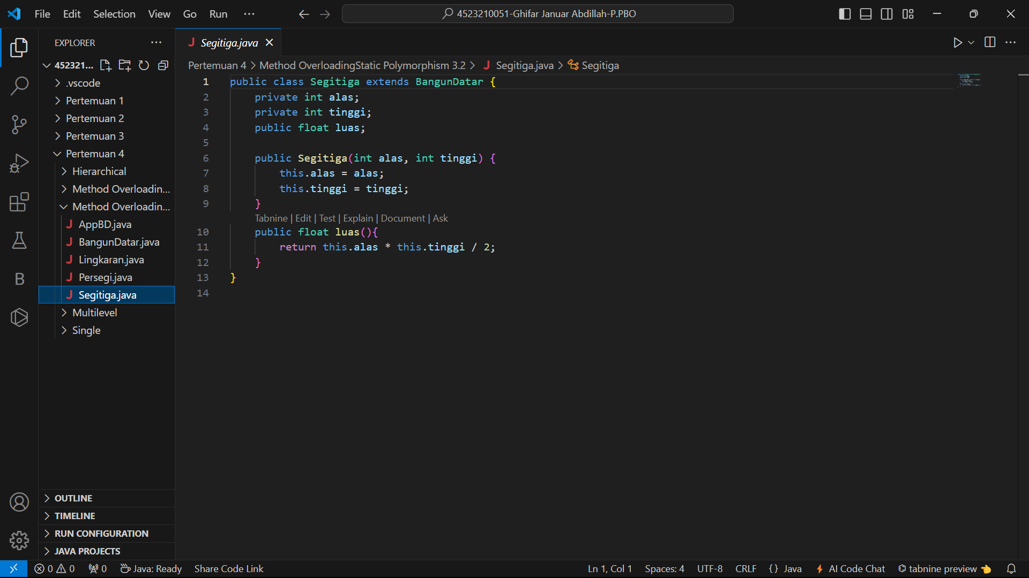

## Lingkaran.java

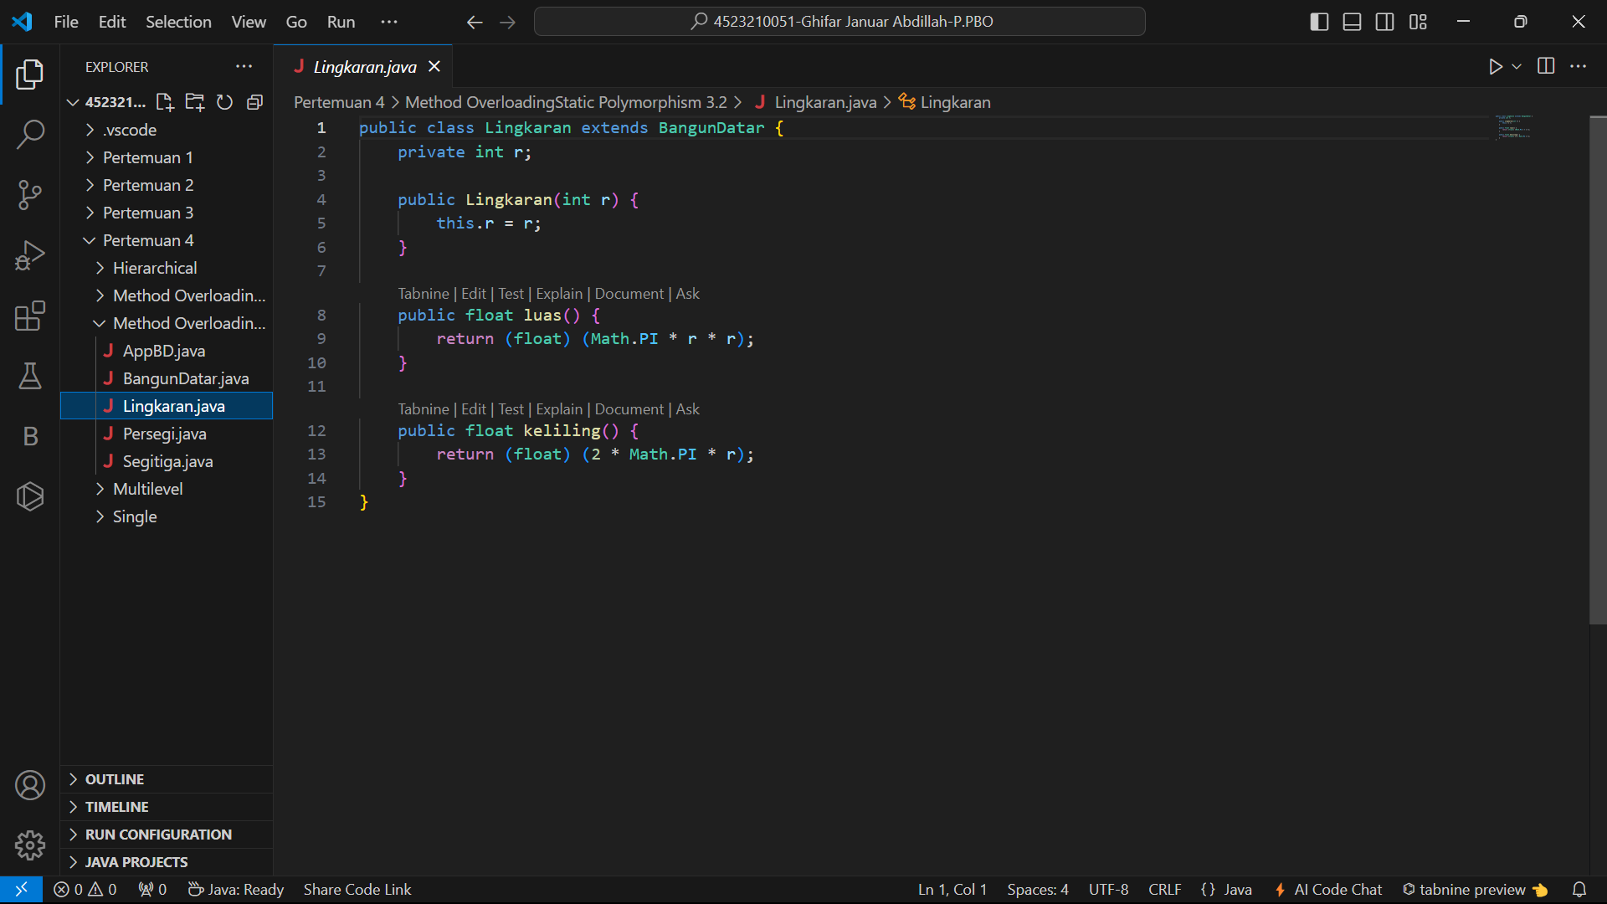

## AppBD.java

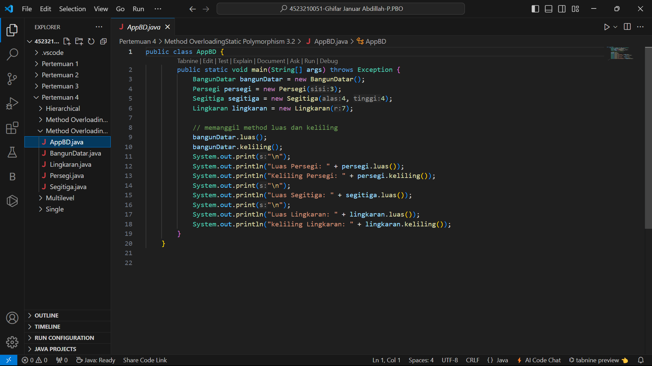

# Hasil Runinng

